Lab 6

Instructions:
Provide your solutions in a file named lab6.py. Make sure you run the doctest before submitting. Note that you should also test the Scrambler game thoroughly.

Problems:
- Write a class ScoreList that can be used to record a number of course scores (from 0 through 100, inclusive of both) and report information about them. :
>>> s = ScoreList()
>>> s.add(57)
>>> s.passing()
False
>>> s.add(83)
>>> s.add(80.2)
>>> s.add(104) #doctest: +IGNORE_EXCEPTION_DETAIL
Traceback (most recent call last):
...
ScoreError: score 104 not between 0 and 100
>>> s
ScoreList([57, 83, 80.2])
>>> s.avg()
73.39999999999999
>>> s.passing()
True
>>> max( s )
83
>>> min( s )
57
>>> len( s )
3
>>> s[1]
83
>>> s.sort()
>>> s
ScoreList([57, 80.2, 83])
>>>

Parameterized constructor

>>> s = ScoreList( [80,30,100] ) # this is ok
>>> s == eval(repr(s)) # test, init, repr, ==
True
>>> s = ScoreList( [80,-10,100])
Traceback (most recent call last):
...
ScoreError: score -10 not between 0 and 100
>>> s = ScoreList( [80,10,110])
Traceback (most recent call last):
...
ScoreError: score 110 not between 0 and 100
>>>

Implementation details:
- ScoreList should inherit from list (note that this automatically provides some of the above functionality)
- constructor – constructs either an empty list, or initializes with a list of values (note that this may cause a ScoreError if some score is out of range).
- __repr__ - to produce the output above
- add()
  - accepts one number
  - if the provided number is at least 0 and at most 100, it is added to the ScoreList
  - otherwise, an Exception is raised (see output above for message)
- avg()
  - takes no arguments
  - returns the average of the scores on the list
- passing()
  - takes no arguments
  - returns True if the average is at least 60, False otherwise

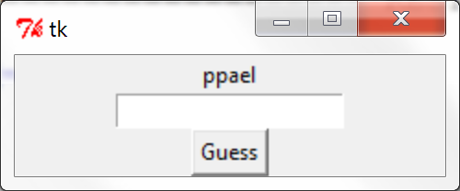
- Write a tkinter game Scrambler, that allows the user to guess a scrambled word. The game is started by giving a word and packing. The parent can be specified or omitted, e.g, either:

>>> Scrambler("apple").pack()
>>>

Or
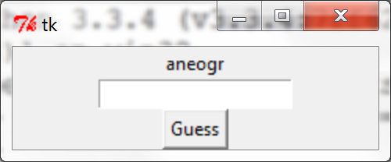
>>> root = Tk()
>>> Scrambler("orange",root).pack()
>>>
The game will then scramble the word and display it in the gui, see images to the right. The user will then have 3 guesses to guess the original word. (To scramble a word, make sure you add the import “from random import *”, then use the following code.

scramble = list( word )
shuffle(scramble)
scramble = ''.join( scramble) # this is now the scrambled word

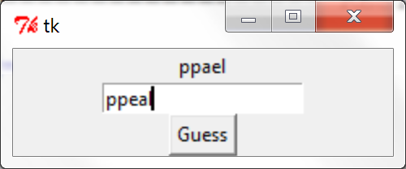
To guess a word, the user types in the Entry and clicks the button. The game then checks the guess against the original. There are three possibilities:
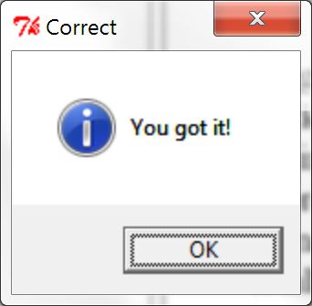
- The guess is correct, then the user is told “You got it” in a showinfo.
- The guess is incorrect, and there is at least 1 guess left. Then the user is told the number of guesses left.
- The guess is incorrect, and no guesses are left. The user is told “You lose”

